21BDS0340

Abhinav Dinesh Srivatsa

Probability and Statistics Lab

Lab Assessment – III

**Part a**

Code:

print(paste("All bulbs good: ", dbinom(20, 20, 0.1)))

print(paste("At most 3 defective bulbs: ", pbinom(3, 20, 0.1)))

print(paste("Exactly 3 defective bulbs: ", dbinom(3, 20, 0.1)))

Output:

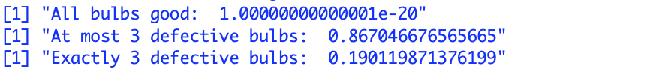

**Part b**

Code:

print(paste("Exactly 3 red balls: ", dpois(3, 50 / 1000 * 60)))

print(paste("Not more than 3 red balls: ", ppois(3, 50 / 1000 * 60)))

Output:



**Part c**

Code:

print(paste("More than 2150 hours: ", 1 - pnorm(2150, 2040, 60)))

print(paste("Less than 1050 hours: ", pnorm(1950, 2040, 60)))

print(paste(">1920 and <2160 hours: ", pnorm(2160, 2040, 60) - pnorm(1920, 2040, 60)))

Output:

